Messup Java/Python comparison

# Java

## Dev time

2 hours

## Run time

12 milliseconds

## Lines of code

111 lines of code including the main function and our class

## Memory Usage

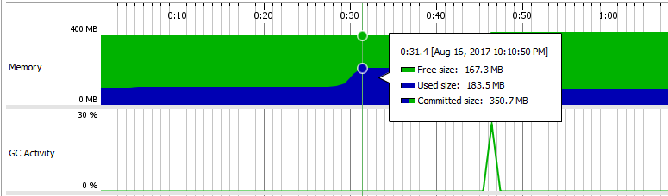

We've used JProfiler to capture a memory snapshot  
The program created a rise of about **16 MB** in memory usage.

# Python

## Dev time

0.5 hours

## Run time

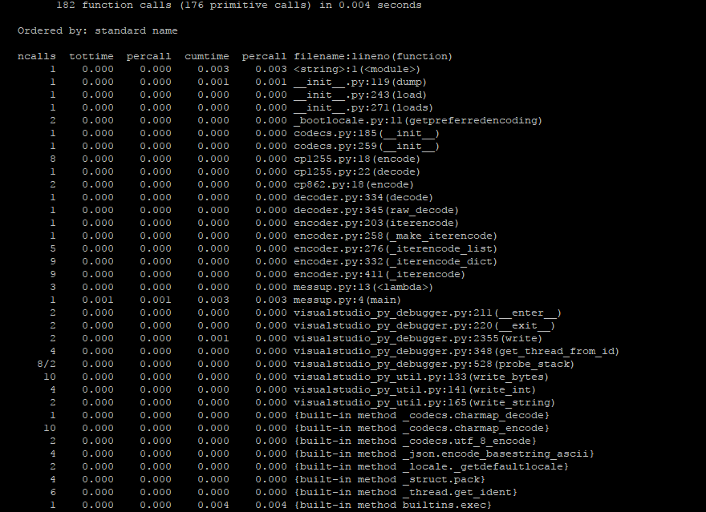

We've used the cProfile python module to measure the execution time.  
the code run for 0.004 seconds as can be seen

## Lines of code

21 lines

## Memory Usage

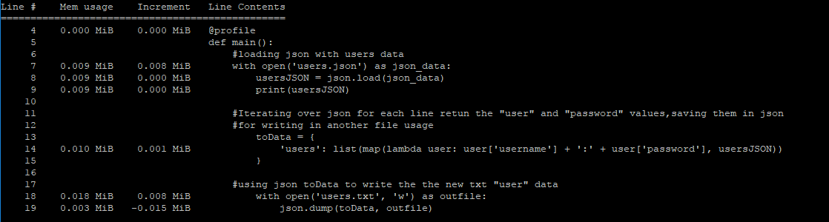

We've used the memory_profiler python module in order to profile the memory usage.  
the code increments the start memory by **0.018 MB**